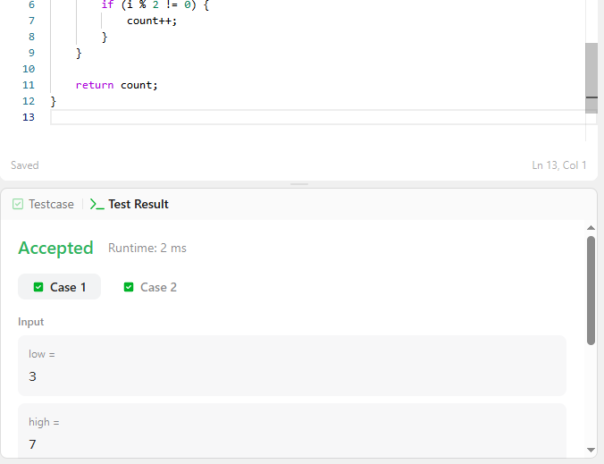

CODE-

int countOdds(int low, int high) {
int count = 0;

for (int i = low; i <= high; i++) {
if (i % 2 != 0) {
count++;
}
}

return count;
}

LINK-
https://leetcode.com/problems/count-operations-to-obtain-zero/

